Sellers pack
Ticketed sale
NCT Lichfield & Tamworth Branch

Branch Name: Lichfield and Tamworth

Date of sale: 23rd November 2024

Venue address: Boley Park Community Hall, 7 Ryknild Street, Staffordshire, WS149XU

Drop off items time: 8.30am – 8.45am

Parking information: Large carpark shared with the shopping area

Volunteer pre-sale time: 10am – 10.30am approximately

NCT Members admission time: 10.45am approximately

Public admission time: 11am approximately

Sale close time: 12.30pm
Collect unsold items time: 2.30pm – 3.30pm
Email for seller enquiries: nns.lichfieldandtamworth@nct.org.uk
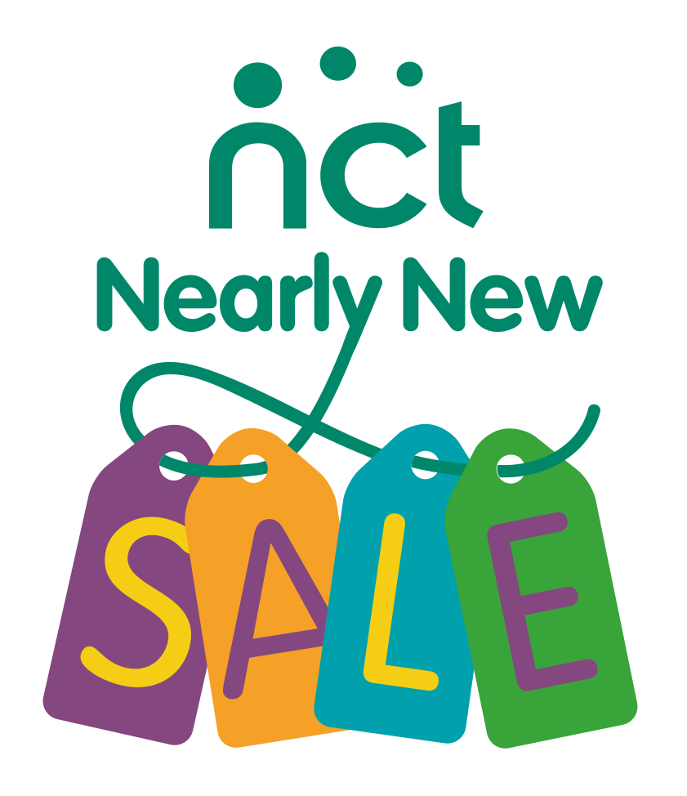

Thank you for signing up to sell at our next NCT Nearly New Sale. Our sale is a great way of raising awareness and funds for the work of the charity.

To ensure that the sale runs smoothly please read through this guidance.

Please arrive to drop off/put out your items between 8.30am and 8.45am. You can collect your items from 2.00pm approximately, please keep an eye on socials for early collection updates. Any uncollected items will be collected by a charity/disposed of. Please be aware that volunteers will not have room in their cars to transport left over items.

Goods at sales
We sell maternity goods, parenting goods, children’s clothes (1 year - 7 years only), toys, books and equipment up to age 7.

In our experience newborn and 0-1 year clothes do not sell that well at our sales. As a result we will not accept them at our sales.
There are a few items we cannot sell, and some restrictions. These are listed in our Nearly New Sale Principles on our website. All sellers MUST read and abide by our Nearly New Sale Principles.
https://www.nct.org.uk/local-activities-meet-ups/nct-nearly-new-sale-sellers-principles
Hints and Tips
Clothing tends to sell better if it is in the current season. E.g., this sale is taking place in May, so bring Spring and Summer clothes. We will hold another sale later in the year where winter clothes can be sold, as it will be closer to Winter.
How much money can I keep?
For all the items that you sell you will take home 70% of the sale price. NCT takes a 30% commission which goes towards the charity’s national work and to support local parents, preparing them for birth and early parenthood.

How should I prepare & price my items?
- Please price items in multiples of 50p. (£1.00, £1.50, £2.00 etc.).
- Pricing is up to you but bear in mind that if you price things highly they may not sell. Many high street outlets are selling clothing very cheaply now, even quality brands, so price your items competitively.
Most sellers use the following guidelines:
- Babygro’s – 50p to £1, Cardigan/Jumpers – £1 to £3
- Coats/Jackets – £2 to £5, Dresses – £2 to £5
- Trousers/Jeans – £1 to £4, Shoes/Wellies – £1 to £3
- Highchairs £5 upwards, Stairgates £5 upwards
- Children’s bikes £5 upwards, Small slide £5.

How should I label my items?
We use a two part label system to increase accuracy and speed up payment at the tills. At the checkout, half the label will be cut off and retained and half will remain attached to the item. Please use the labels provided to mark up your goods before the sale.
Both halves of the label should display the same information. Please attach just one half of the label to your items (LEFT HALF) – the other half (RIGHT) needs to be easily removed at the tills. Labels need to be attached securely to items (not to hangers) using safety pins/tape/string/tag gun. Please ensure the item is not damaged by the label attachment e.g. use masking tape for books.
For security reasons we do not sell items without a label attached. So no label = no sale and the item can only be returned to you if you pick it from the “lost labels” table at the end of the sale. We do not allow altered labels through the till as we cannot be sure if a buyer has altered the label – so if you make a mistake – use a new label.
e.g.

Seller: 085  This side is  attached to the item | Seller: 085
 | This side is removed and retained at the till
Item: Boys jeans | Item: Boys jeans
Age/Size: 2-3yrs | Age/Size: 2-3yrs
Price: £3 | Price: £3

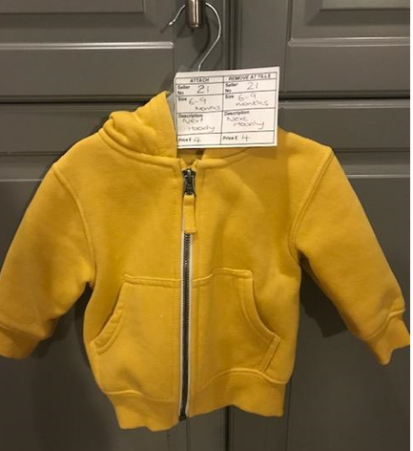
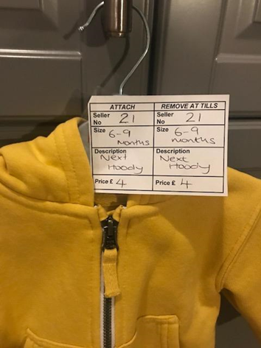

How should I package my items?
- Bring your items in cardboard boxes/bags with your seller number clearly marked on them.
We will sort your unsold items back into these at the end of the sale.
- When packing your bags, pack similar items together for example baby equipment together, toys for a 1 year old together etc. Please help us to make it as easy as possible to display your items quickly, so we can be ready for the sale opening time.
- Clothing can be displayed on hangers. You must supply the hangers, and these will be sold with the item so will not be returned to you.
- If your item contains detachable pieces, e.g. equipment or toys, then be sure they are attached firmly to the item so they cannot be lost.
- If you have the original packaging and or instructions please include them – where practical don't tape it shut as people who can't check the goods inside may be reluctant to buy it.

What happens when I arrive at the venue?
- Please park sensibly and be patient as there will be a lot of people arriving with lots of items.
- Please sign in at the seller registration desk.
- You will be given advice on where to put your items, volunteers will put your items out for you. If you can help it would be much appreciated.

What happens after the sale?
- After the sale your items will be sorted into the labelled box/bag you provided and will be available for you to collect between 2.00pm and 3.00pm. If you arrive at 2.00pm and we are not ready you will have to wait. If you can arrive before that time to help, it would be appreciated. We have your mobile number from registration so we will call you if we are any earlier. Please do not be later that 3.00pm as we have to be out of the hall.
- Make sure that you also check the lost labels table. Please check your box before you leave to ensure all items belong to you. Although volunteers make every effort to ensure things go back into the correct box, errors can happen.
- Please note that, whilst we do our best to provide reasonable security at sales, all items are left at the venue at the seller’s risk. NCT does not accept liability for any loss or damage caused to goods for sale.
- We recommend you register for payment by BACS when you register, you will then receive a BACS payment within one month of the sale. Please ensure you put in the CORRECT bank details as this is a common error and will mean money will bounce, or if it is a valid account, we are unlikely to get the money back. If you do not put bank details, a cheque will be sent, but this may take longer.
- Please note that labels will only be sent back to you if requested and £1.65 admin fee will be taken from your proceeds. If the labels are ready when you collect your items, you can take them then, but we cannot guarantee this.
- Please let us know if you have not received your money a month after the sale.

Faulty items
Please ensure you check items before putting them into the sale. If an item is battery operated, we recommend you sell it with batteries so that buyers can see it works. If you have not used an item for a while, please check the battery compartment to ensure batteries have not corroded.
If we are contacted by a buyer to say an item is faulty, we will contact you and with your permission, put you in contact with the buyer, so you can arrange a refund.

Cancellation
If you need to cancel your seller space we will refund your seller fee up to 2 weeks before the sale. After this there is no refund offered.
Advertise – get buyers in to buy your goods!
Whilst we at NCT promote the sale, it is in all sellers’ interests to maximise the number of buyers through the door. Please can we ask that you tell people about the sale, use our sale flyer to publicise the event (for example, at your place of work, in your car window, in your porch) and tell your friends on Facebook (or share our branch page/event) so that we can make this sale the most successful ever.
Volunteering
- The success of our Nearly New Sales depends entirely on our fantastic team of volunteers.
- We always welcome new volunteers and there are several different roles available on the day and in the run up to the sale. To thank you for your efforts all volunteers are invited to join in the presale shopping before the doors are open to the public.
- To find out more about what volunteering involves, get in touch with us at nns.lichfieldandtamworth@nct.org.uk

NCT Nearly New Sales are very important to NCT and local parents. We hope you have a truly positive experience and will choose to sell with us again.
If you have any questions about the sale after reading all the guidelines, please do not hesitate to email us. Please note that the sale is run entirely by volunteers, most with young children, so bear with us if we do not get back to you immediately.
If you have any other comments or suggestions about our NCT Nearly New Sales then please don’t hesitate to contact the Nearly New Sale Coordinator.
Email: nns.lichfieldandtamworth@nct.org.uk

Our next sale date is to be confirmed

We really need new volunteers to lead and organise, before the day, or there may not be sales in 2025. Please get in touch!

